Home Page

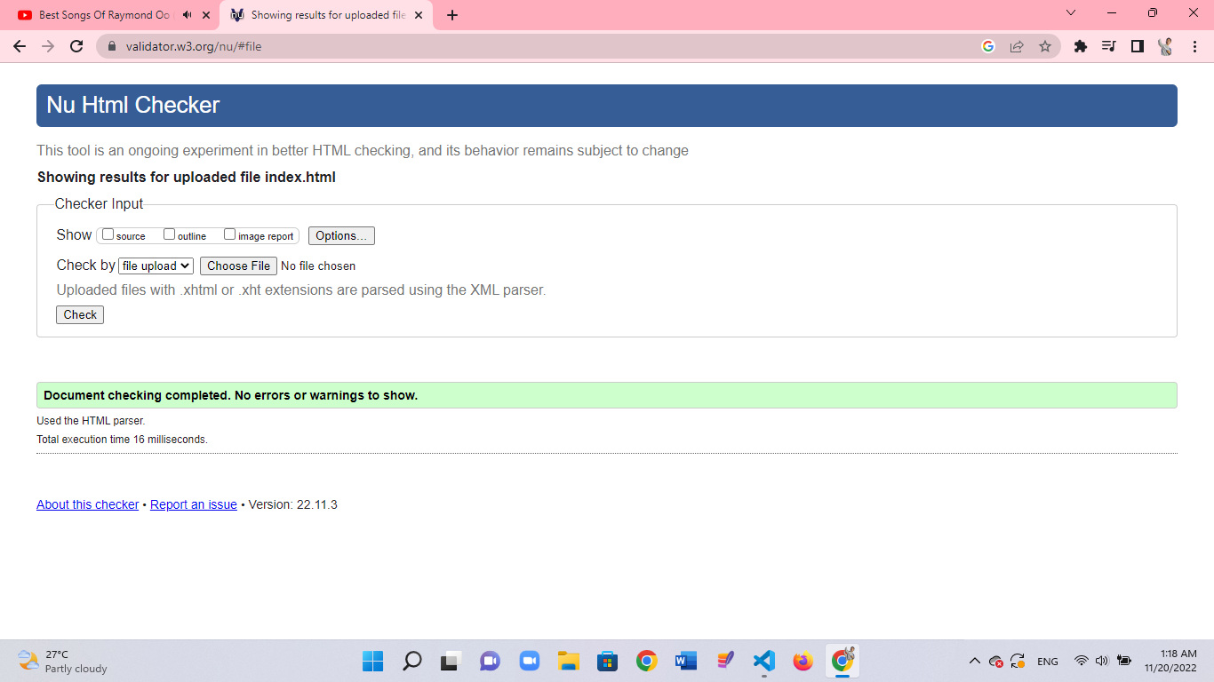

ContactUs Page

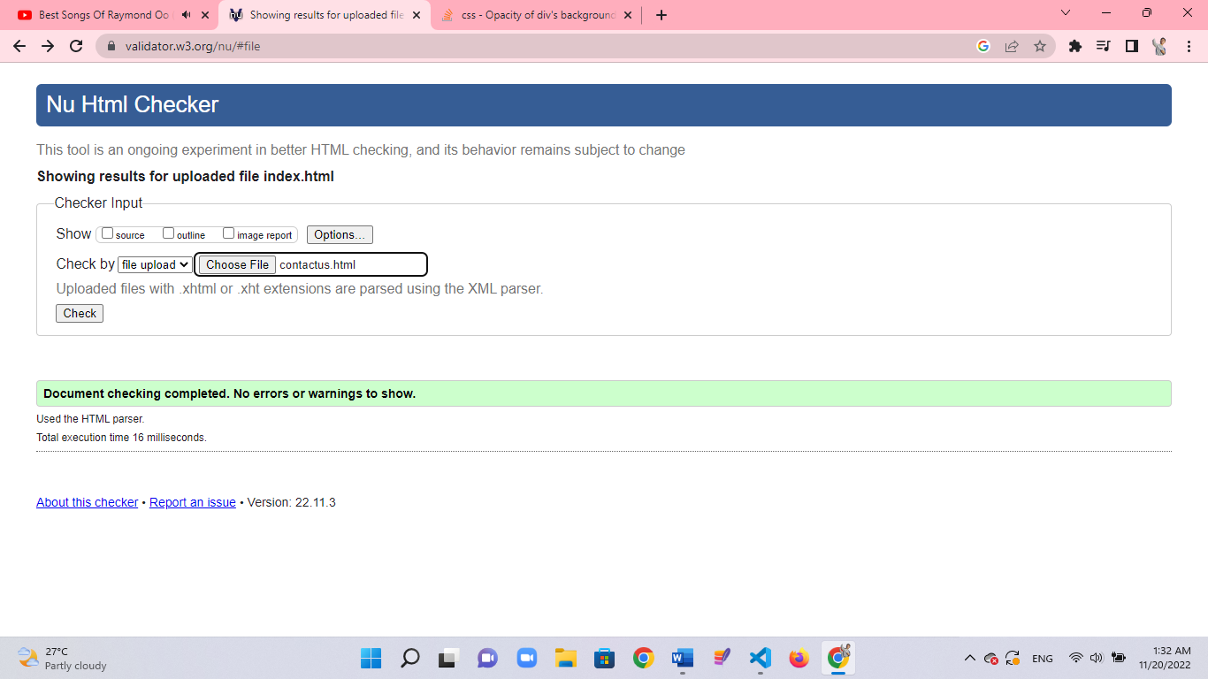

AboutUs Page

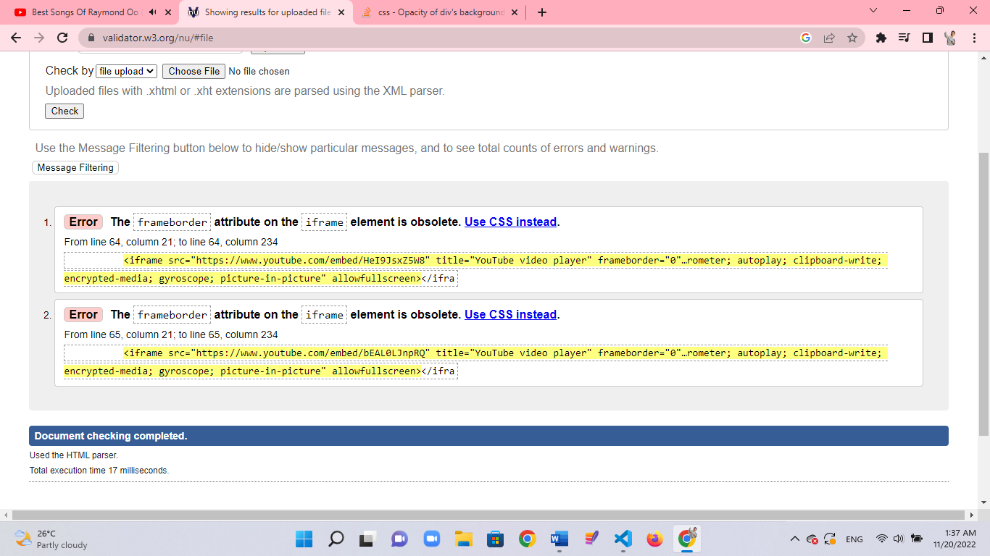

This error showed that frameboder is no longer used in html5. Instead of using this attribute, stying with css resolved this problem.

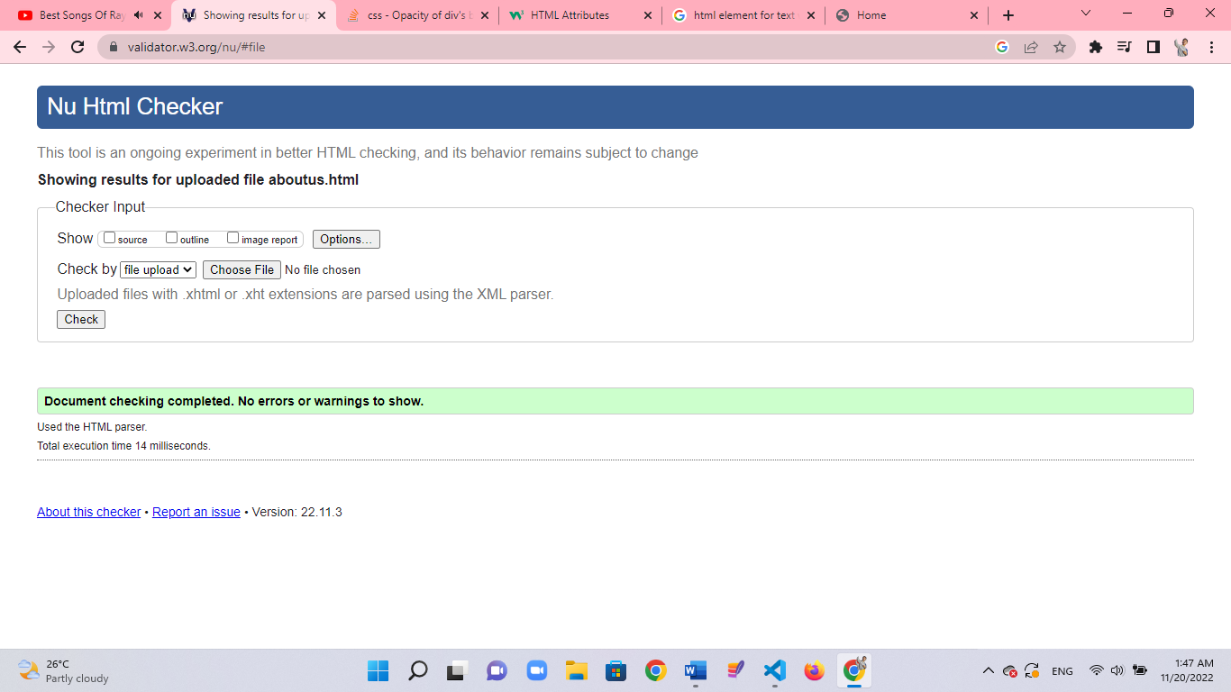

Our Driver

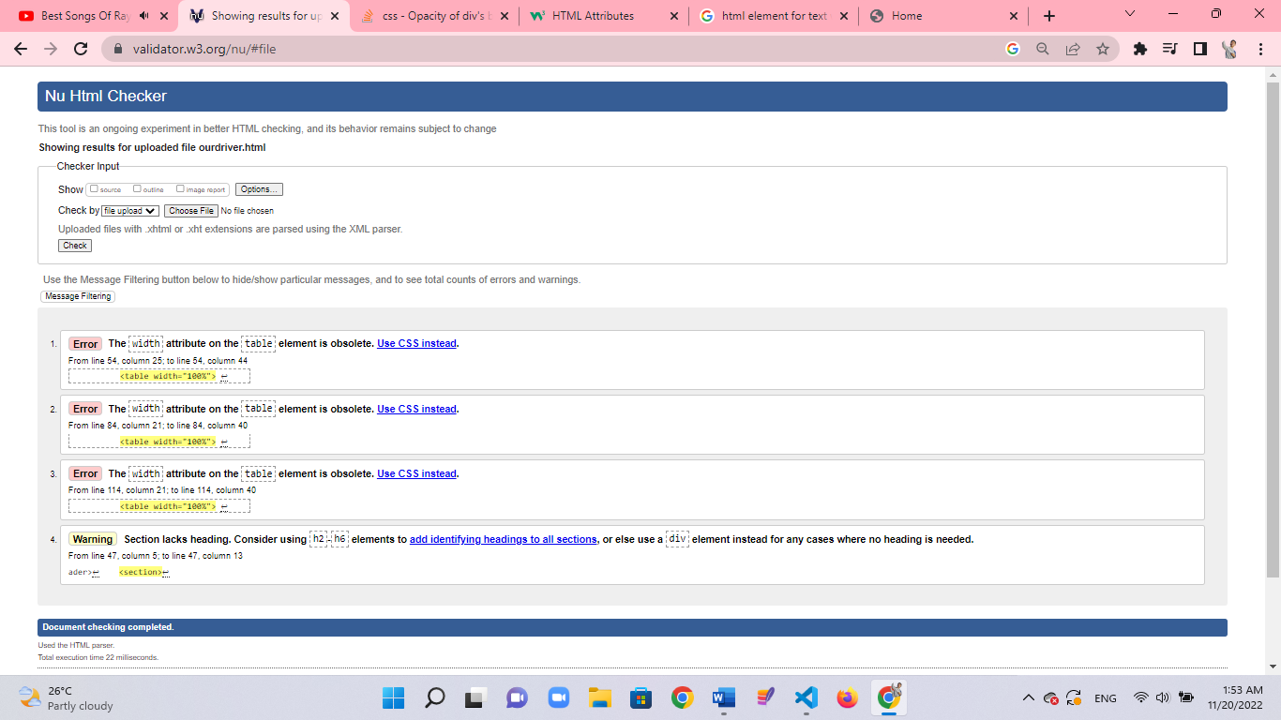

No 1 to 3 errors also showed that width attribue on table element is no longer used in html5. Instead of giving with properties to table element in css resolved this problem.

No 4-error point out that section can’t be lack heading tag. By adding h2 to h6 element or by covering with div element, this error can be erased.

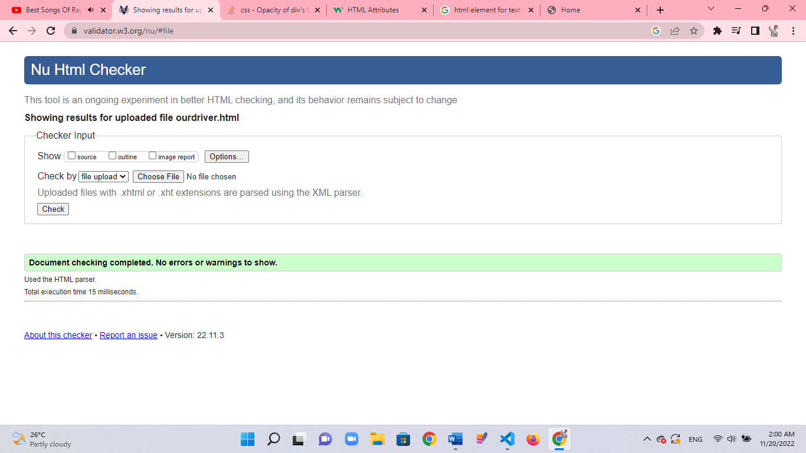

Question and answers page

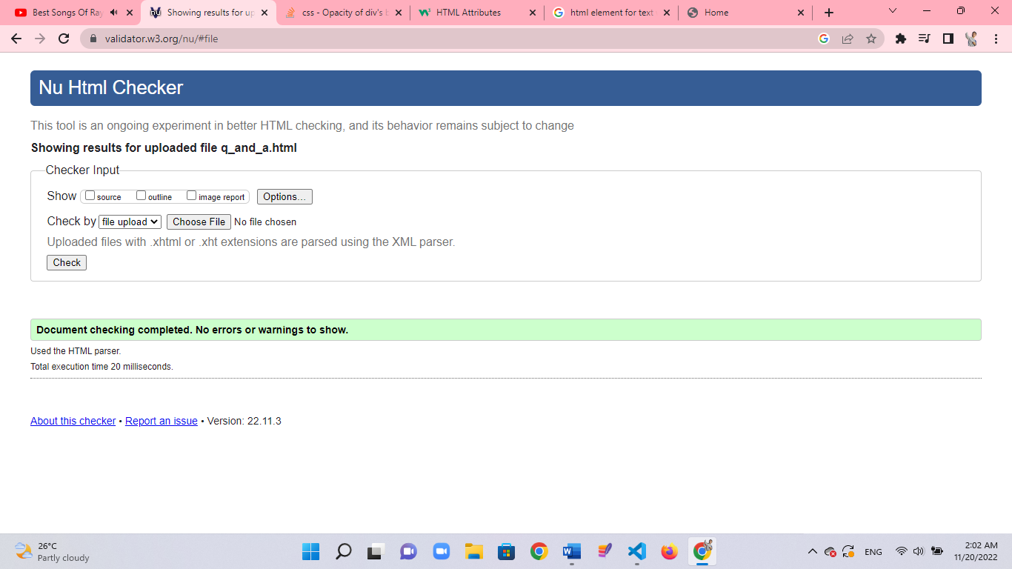

Register Page

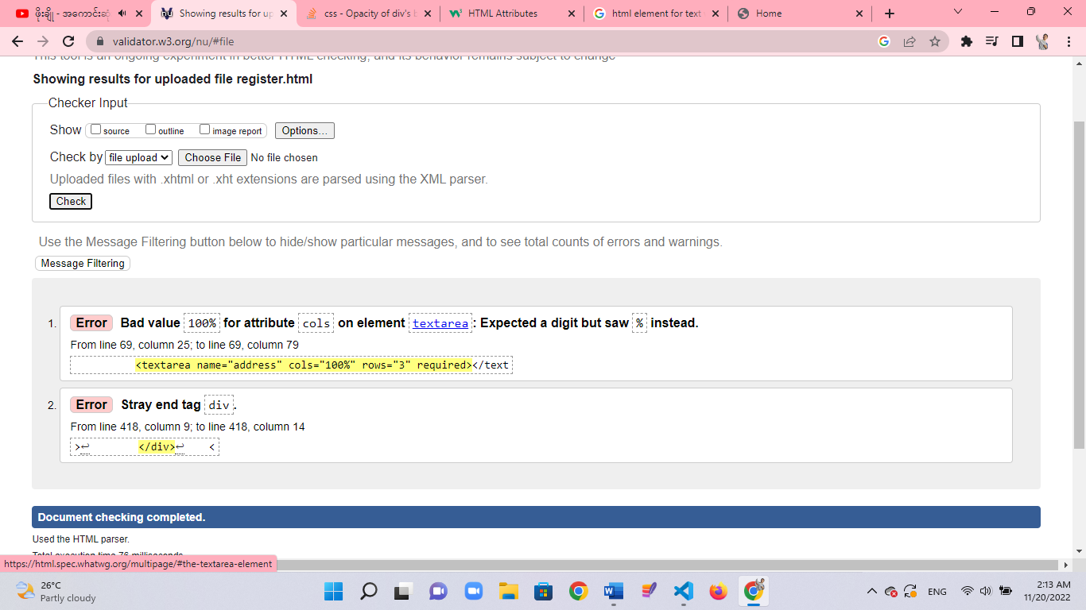

The first error told that col attribute can accept digit but not percentage. Chaning this resolved the problem.

The second error showed that one extra div elemet present. Removing this resolved the problem.

**Testing for different browsers**

The website work properly on different web broswers. When testing on microsoft edge and chrome, can’t see no big changes. But when testing on firefox a few differeces can be seen. These are shown in below.

**Testing on microsoft**

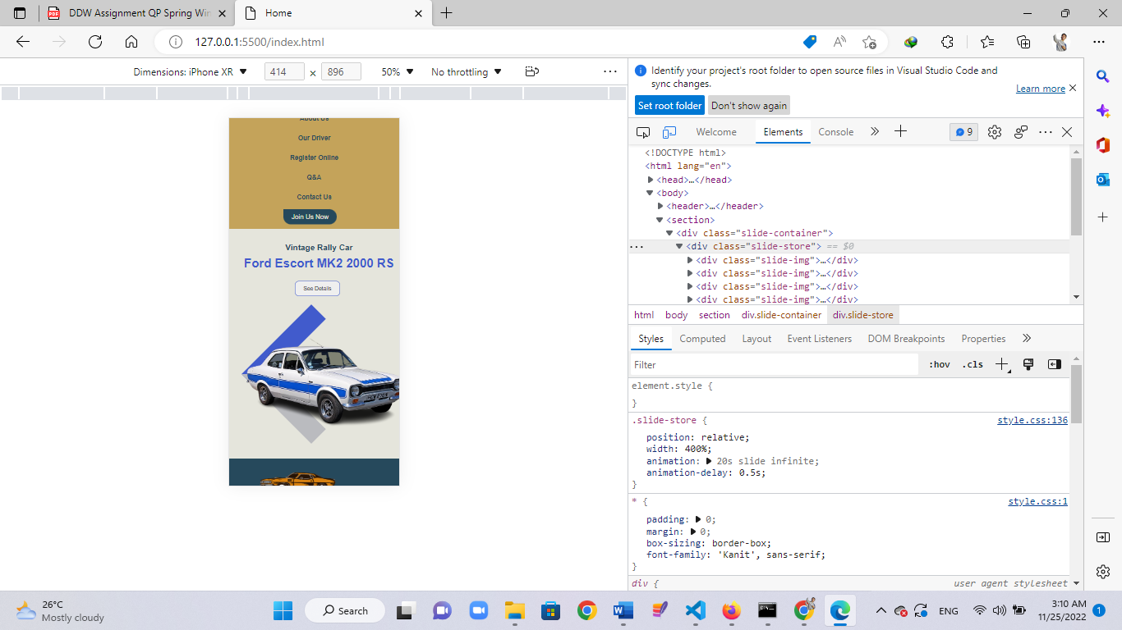

**Testing on chrome**

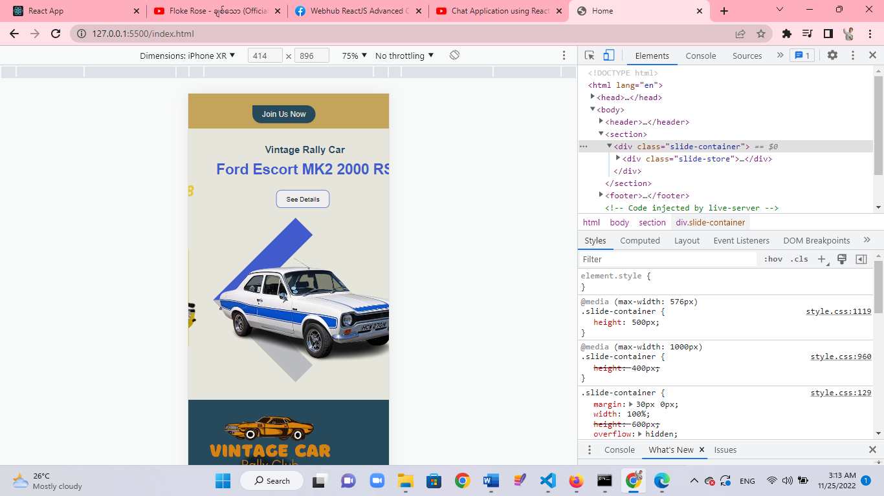

The slider componet work properly on both chrome and microsoft edge.

But in firefox, the title reaches under navigaion bar.

**Testing on firefox**

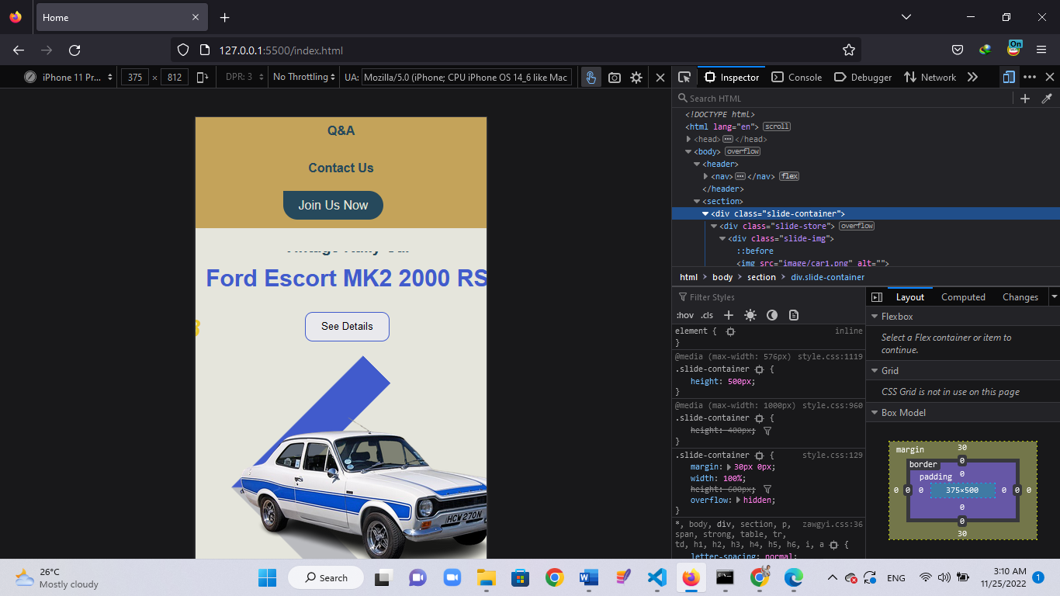

This problem occurs because of giving absolute value to title. The diffent web browsers have diffent view height and view with. The given value cannot be equal for all web browsers.

**The role of W3C**

The long form of W3C is World Wide Web Consortium. The W3C's goal is to create technical standards and guidelines for web technologies worldwide. These standards are intended to keep a consistent level of technical quality and compatibility concerning the World Wide Web. Developers who create web applications can have confidence in the tools they're using, as web applications using these standards have been vetted by experts. An example of a W3C standard is web browsers. Most use W3C standards, which enables them to interpret code such as Hypertext Markup Language (HTML) and Cascading Style Sheets (CSS).

**Task 4**

1. The website should be easy to access for all users. So that the information can be reached to all people no matter they have some issues.

* Using bright color is good for people with low vision or a visual impariment. In this website, many bright colors and high contrast can be seen in entire page. In this way, besides young people, elderly people or people with color deficiences will not struggle to access the information that are given.
* Website users can be non-educated person. If they can’t read information that are given, these will be useless for them. For this problem, most useful buttons are attached with icons that can tell what the written text mean like socail media icos, arrows and symbols.